# Exercise: Simple XAML Layout

Using a stack layout, create a simple calculator app that allows the user to enter two numbers, choose an operation (Add, subtract, divide, or multiply), and view the result. For now, just target the Android platform for testing purposes.

The end result will look something like this:

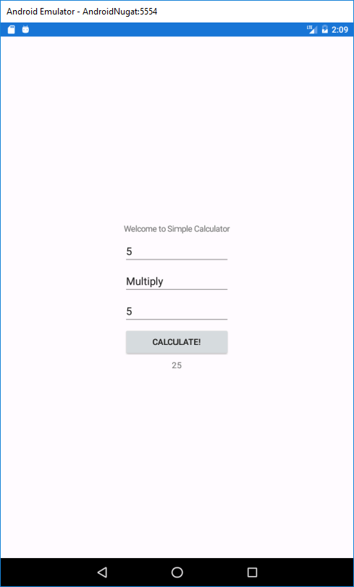

You can use an Editor control for reading input, a Label for output, a Button for initiating the calculation, and a Picker for choosing the operation.

Get started with XAML: <https://docs.microsoft.com/en-us/xamarin/xamarin-forms/xaml/xaml-basics/get-started-with-xaml?tabs=windows>

For the picker, look at the documentation at <https://developer.xamarin.com/guides/xamarin-forms/user-interface/picker/populating-itemssource/>. You can read the selected item using the SelectedItem property and calling ToString if needed.

StackLayout <https://docs.microsoft.com/en-us/xamarin/xamarin-forms/user-interface/layouts/stacklayout#:~:text=A%20StackLayout%20organizes%20child%20views,that%20contains%20other%20child%20layouts>.

Operator +=: <https://docs.microsoft.com/en-us/dotnet/csharp/language-reference/operators/addition-operator>

Solution

MainPage XAML:

<StackLayout HorizontalOptions="CenterAndExpand" VerticalOptions="CenterAndExpand">

<Label Text="Welcome to Simple Calculator"

VerticalOptions="Center"

HorizontalOptions="Center" />

<Editor x:Name="ed1" />

<Picker x:Name="spinOp" HorizontalOptions="FillAndExpand">

<Picker.ItemsSource>

<x:Array Type="{x:Type x:String}">

<x:String>Add</x:String>

<x:String>Subtract</x:String>

<x:String>Divide</x:String>

<x:String>Multiply</x:String>

</x:Array>

</Picker.ItemsSource>

</Picker>

<Editor x:Name="ed2" />

<Button x:Name="clickCalculate" Text="Calculate!" />

<Label Text="" x:Name="result"

VerticalOptions="Center"

HorizontalOptions="Center" />

</StackLayout>

App.xaml.cs:

public App ()

{

InitializeComponent();

MainPage = new XamEx1_SimpleCalc.MainPage();

var ed1 = MainPage.FindByName<Editor>("ed1");

var ed2 = MainPage.FindByName<Editor>("ed2");

var button = MainPage.FindByName<Button>("clickCalculate");

var result = MainPage.FindByName<Label>("result");

var spinOp = MainPage.FindByName<Picker>("spinOp");

button.Clicked += (sender, e) =>

{

switch (spinOp.SelectedItem.ToString())

{

case "Add":

result.Text = (Convert.ToDouble(ed1.Text) + Convert.ToDouble(ed2.Text)).ToString();

break;

case "Subtract":

result.Text = (Convert.ToDouble(ed1.Text) - Convert.ToDouble(ed2.Text)).ToString();

break;

case "Divide":

result.Text = (Convert.ToDouble(ed1.Text) / Convert.ToDouble(ed2.Text)).ToString();

break;

case "Multiply":

result.Text = (Convert.ToDouble(ed1.Text) * Convert.ToDouble(ed2.Text)).ToString();

break;

default:

result.Text = "None";

break;

}

};

}